Andrew Morris

Professor John

IT-230

February 9th 2025

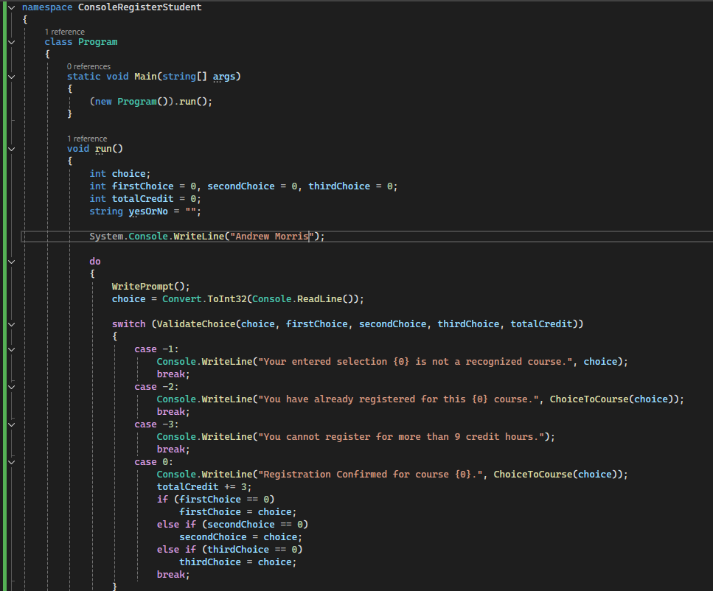

When it comes to what this part of the code does, the firs thing is it sets up the variables of choice, firstchoice, secondchoice, and thirdchoice. Then it prints out different instructions on what the player would need to do and if the player entered something that didn’t work or if they picked too many courses. This also sets up placing the variables in the print for telling someone that their registration is completed and shows what class they are in.

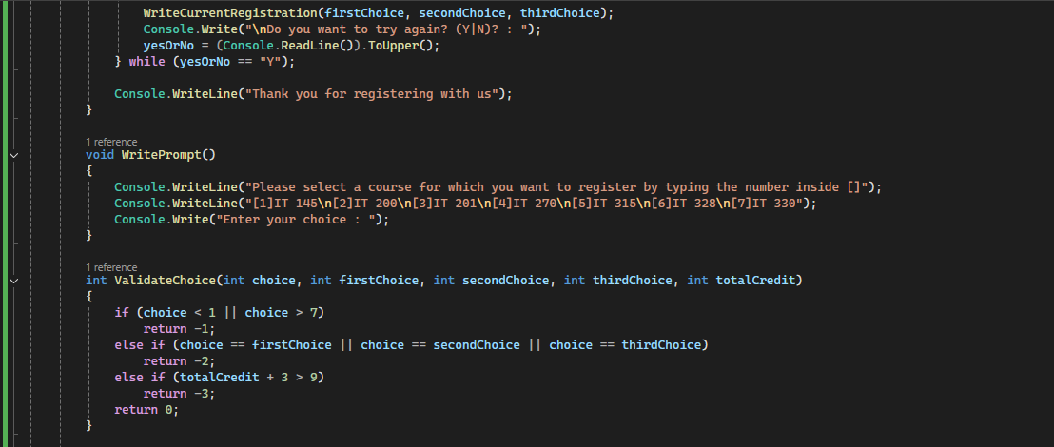In this section it starts off with printing the 3 variables of the classes the user has picked but then asks if they would like to try again. This then goes to tell if the user thanks you for registering with us if they selected no and if they selected yes then it repeats. Not to mention after this the code goes to tell the user what to select and the options on what you can pick from. Finally, the last bit of the code relates to the variables and produces outputs depending on how much courses the user has picked out.

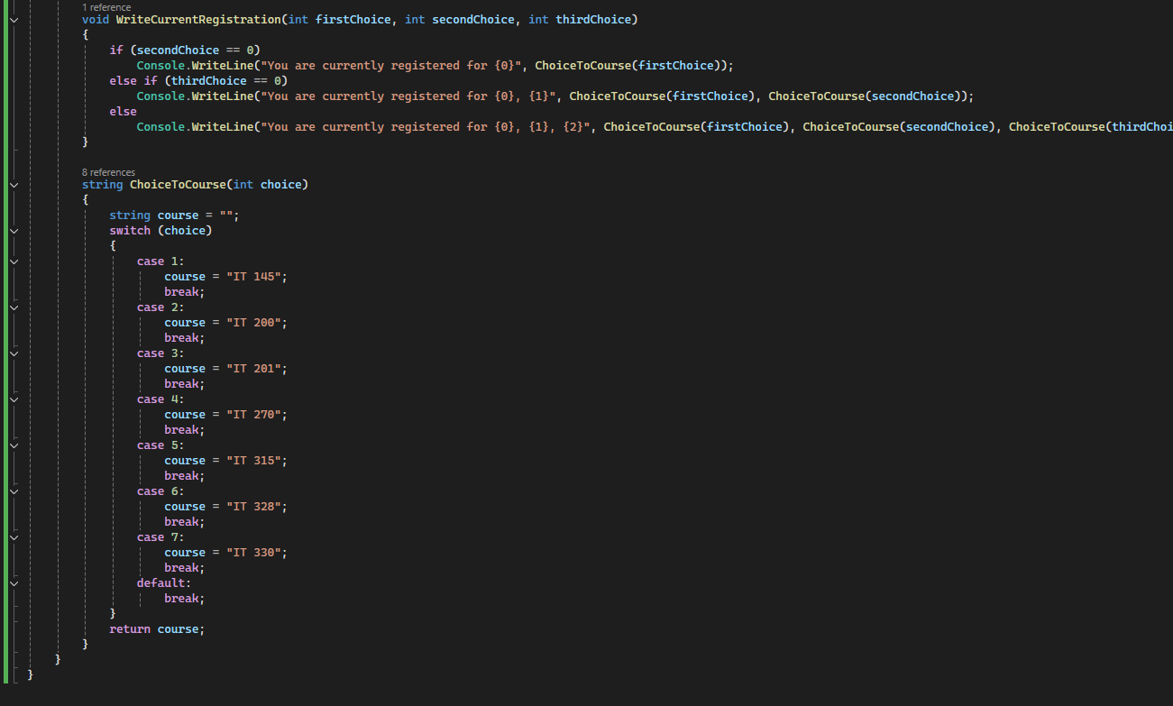

For the last bit of code we first start with the display messages that the user will see that tells them what classes they’re in and just like a lot of the code, it’s also dependent on how much of the classes the user had registered in. Finally, it shows each of the classes and each number that the user would need to put in to register for the class. Now that the code is explained let’s look at the output!  
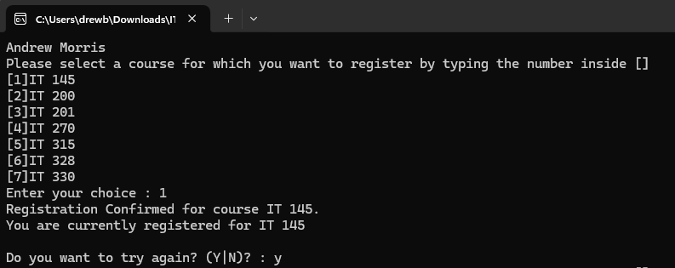The fist part of the output focuses on the first section of the output which allows the user to pick out their first class. Once they insert a number that works then they can decide if they want to keep going. Not to mention this displays all of the options that people can pick from.

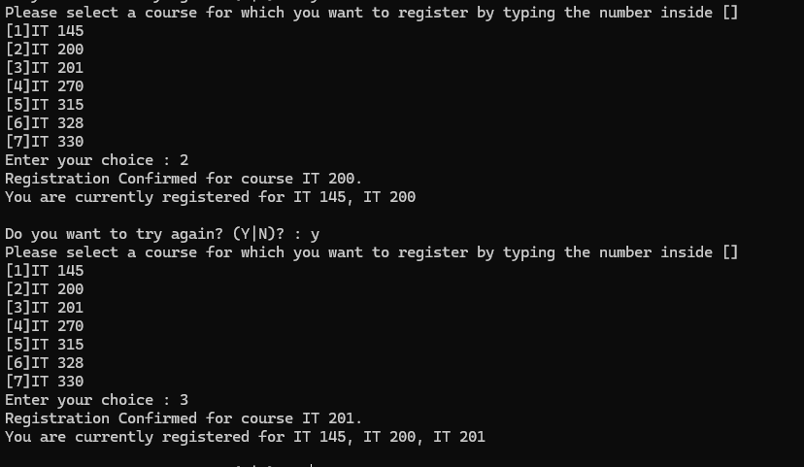This next part goes over the fact that people can select up to 3 courses by selecting their course and then pressing y for if they wanted to keep going.

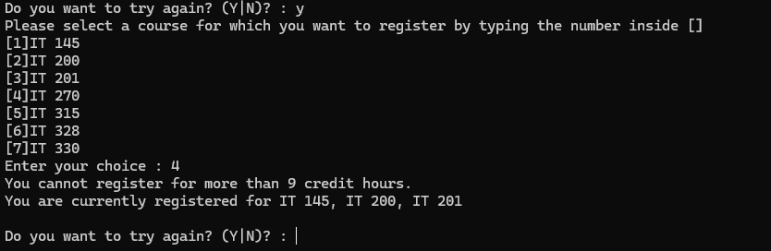This part here goes over and shows that people cannot go over 3 classes and displays a message on if they go over the limit.



This bit of the output just goes over what happens if you press no and it will output saying thank you for registering with us.

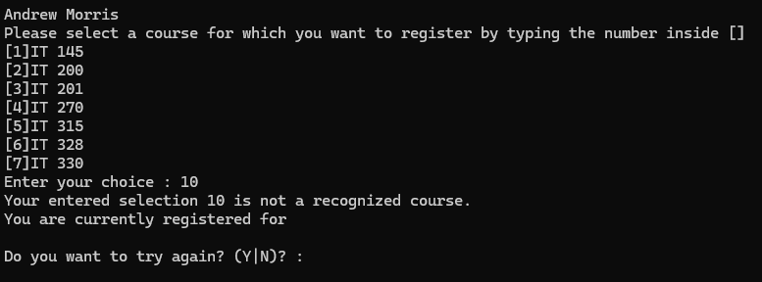This part of the code just goes over on what happens if you put a number in that doesn’t have a class attached to it.

Source code:

namespace ConsoleRegisterStudent

{

class Program

{

static void Main(string[] args)

{

(new Program()).run();

}

void run()

{

int choice;

int firstChoice = 0, secondChoice = 0, thirdChoice = 0;

int totalCredit = 0;

string yesOrNo = "";

System.Console.WriteLine("Andrew Morris");

do

{

WritePrompt();

choice = Convert.ToInt32(Console.ReadLine());

switch (ValidateChoice(choice, firstChoice, secondChoice, thirdChoice, totalCredit))

{

case -1:

Console.WriteLine("Your entered selection {0} is not a recognized course.", choice);

break;

case -2:

Console.WriteLine("You have already registered for this {0} course.", ChoiceToCourse(choice));

break;

case -3:

Console.WriteLine("You cannot register for more than 9 credit hours.");

break;

case 0:

Console.WriteLine("Registration Confirmed for course {0}.", ChoiceToCourse(choice));

totalCredit += 3;

if (firstChoice == 0)

firstChoice = choice;

else if (secondChoice == 0)

secondChoice = choice;

else if (thirdChoice == 0)

thirdChoice = choice;

break;

}

WriteCurrentRegistration(firstChoice, secondChoice, thirdChoice);

Console.Write("\nDo you want to try again? (Y|N)? : ");

yesOrNo = (Console.ReadLine()).ToUpper();

} while (yesOrNo == "Y");

Console.WriteLine("Thank you for registering with us");

}

void WritePrompt()

{

Console.WriteLine("Please select a course for which you want to register by typing the number inside []");

Console.WriteLine("[1]IT 145\n[2]IT 200\n[3]IT 201\n[4]IT 270\n[5]IT 315\n[6]IT 328\n[7]IT 330");

Console.Write("Enter your choice : ");

}

int ValidateChoice(int choice, int firstChoice, int secondChoice, int thirdChoice, int totalCredit)

{

if (choice < 1 || choice > 7)

return -1;

else if (choice == firstChoice || choice == secondChoice || choice == thirdChoice)

return -2;

else if (totalCredit + 3 > 9)

return -3;

return 0;

}

void WriteCurrentRegistration(int firstChoice, int secondChoice, int thirdChoice)

{

if (secondChoice == 0)

Console.WriteLine("You are currently registered for {0}", ChoiceToCourse(firstChoice));

else if (thirdChoice == 0)

Console.WriteLine("You are currently registered for {0}, {1}", ChoiceToCourse(firstChoice), ChoiceToCourse(secondChoice));

else

Console.WriteLine("You are currently registered for {0}, {1}, {2}", ChoiceToCourse(firstChoice), ChoiceToCourse(secondChoice), ChoiceToCourse(thirdChoice));

}

string ChoiceToCourse(int choice)

{

string course = "";

switch (choice)

{

case 1:

course = "IT 145";

break;

case 2:

course = "IT 200";

break;

case 3:

course = "IT 201";

break;

case 4:

course = "IT 270";

break;

case 5:

course = "IT 315";

break;

case 6:

course = "IT 328";

break;

case 7:

course = "IT 330";

break;

default:

break;

}

return course;

}

}

}